**AI IN FASHION: Virtual Stylist**

Tanvi Hareesh

Date: 26 July, 2023

**1.Abstract:**

Virtual stylist is an application that merges the capabilities of artificial intelligence and the fashion industry. It makes a fashion stylist available to anyone. This way everyone can receive the best recommendations on how to dress. Not only dressing but can give beauty recommendations on makeup and skincare based on the user’s needs. This app combines computer vision, natural language processing, and machine learning algorithms to provide personalized fashion recommendations and style advice to users. The virtual stylist analyzes users' taste, preferences, body shapes, and clothing choices to curate fashionable outfits that match individual tastes and occasions. The integration of AI technologies into the fashion domain promises to redefine personal styling, making it more accessible, efficient, and tailored to each user's unique fashion sense. This report delves into the architecture, development process, and functionalities of the virtual stylist, showcasing its potential to enhance the fashion shopping experience and transform the way users interact with clothing and accessories and make fashion and style easy for everybody.

**2. Problem Statement:**

The fashion industry is constantly evolving with new trends and styles emerging every season. Everybody wants to be well dressed and well styled for different occasions and times. But unfortunately styling can turn into a challenge for some people or maybe even some people do not want to waste their time on such things but still want to be well-dressed and sharp.

It is said that the first impression is the best impression and hence our appearance matters a great deal when we want to make impressions or do important business. The way we look, or dress sometimes can just create that extra edge required.

The traditional fashion styling process relies heavily on human expertise, which can be time-consuming and costly. Moreover, existing fashion recommendation platforms often fail to deliver accurate and insightful suggestions, leading to optimal user experience. To address these challenges, there is a need for an AI-powered fashion stylist that utilizes advanced technologies such as computer vision, natural language processing, and machine learning algorithms.

The problem statement revolves around developing an efficient, reliable, and user-friendly virtual stylist that can overcome the limitations of existing fashion recommendation systems.

**3. Market Need Assessment**

The fashion industry is a multi-billion-dollar global market that continues to grow rapidly. As consumers increasingly seek personalized and convenient shopping experiences, there is a rising demand for innovative technologies that can cater to individual fashion preferences. People are ready to spend their hard-earned money on various luxury brands. The virtual stylist addresses a significant market need by leveraging artificial intelligence and data-driven algorithms to provide tailored fashion recommendations, personalized styling, and improved user engagement. LVMH (Louis Vuitton Moet Hennessy) was the most valuable luxury brand in the world, with a brand value of about 124.3 billion U.S. dollars in 2022. The LVMH Group's total revenue for the 2021 fiscal year was about 64.2 billion euros. This market/business need assessment evaluates the potential impact of an AI-powered fashion stylist and identifies key drivers for its adoption.

For a lot of people manually browsing through a vast array of clothing options can be time-consuming and overwhelming. This stylist streamlines the shopping process by presenting curated outfits tailored to users' preferences and specific occasions. This saves time for customers and encourages more frequent visits to an actual shopping mall or center. Additionally, the system's ability to recommend cost-effective alternatives allows users to make budget-friendly fashion choices.

Retailers and fashion brands can benefit from incorporating virtual stylists into their business models. Retailers can tailor their product offerings and marketing strategies by gaining insights into consumers' preferences and style choices. This also enhances inventory management, reduces the risk of unsold inventory, and optimizes marketing spending, ultimately leading to increased profitability.

**4. Target Specifications and Characterization**

The beauty of this app is that the target consumer can be all age groups from teenagers to old people. Whether a 15-year-old girl wants an outfit for her birthday party, or a businessman wants a suit for a top meeting or a housewife wants a themed outfit for her kitty party it can all be consulted by the virtual stylist to give the best option that suits the occasion, style, body type and the budget of the consumer. The virtual stylist will provide personalized fashion recommendations based on the user's style preferences, body shape, age, gender, and occasion. The system should learn from user interactions and continuously improve its understanding of individual tastes.

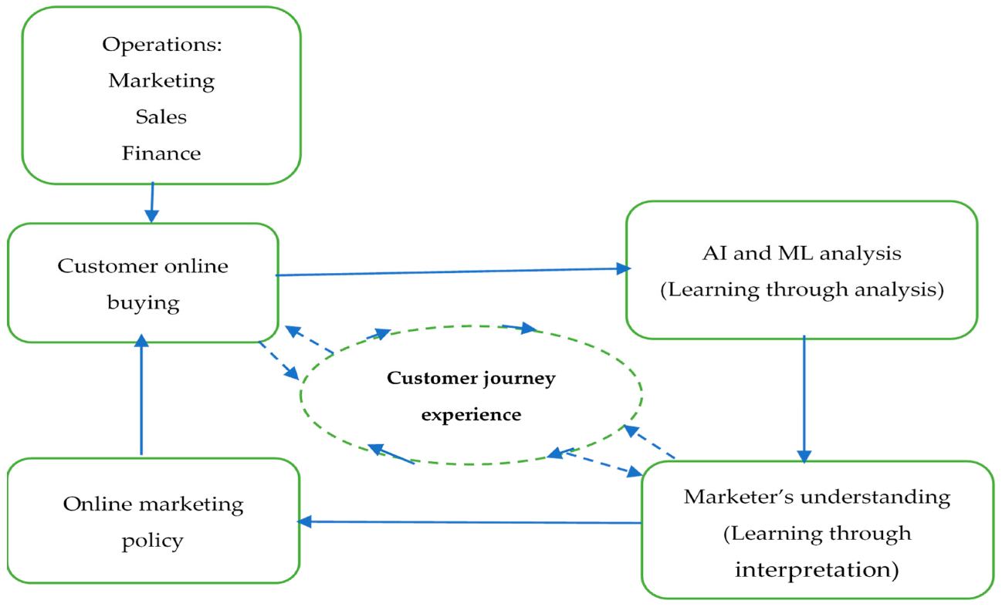

The target consumers can range widely including:

* Busy Professionals: Working individuals with limited time for shopping and styling, seeking a convenient and efficient way to receive personalized fashion recommendations for various occasions.
* Fashion enthusiasts: People who are passionate about fashion and like to try new trends.
* Event attendees: Individuals attending special events, weddings, or traveling to different destinations, seeking appropriate and stylish outfit suggestions for specific occasions.
* Fashion Gift Seekers: People looking for thoughtful and personalized fashion gifts for their friends and family, seeking the virtual stylist's assistance in selecting the perfect items.

**5. External Search**

5.1 How AI Styling Quality Outperforms Human Stylists

The solution to that was to train another model that can detect rich attributes such as its fabric, cut, style, color as well as other unique characteristics and categories for each garment of our dataset. We also work with stylists with experience in brands such as M&S, Topshop, Prada, and Vogue to create a unique set of ‘guidelines’ for our model to give preference to specific attributes when creating an outfit. And of course, because no two regions are the same, we can customize those guidelines to trends. For example, in the Middle East shorter hemlines are always paired with a longer overcoat and in Asia slip dresses should be layered over shirts. The result? A proprietary set of AI and data, that outperforms all published academic research to deliver outstanding styling quality, trusted by the world’s top luxury brands such as D&G, MaxMara and Lane Crawford. We even tested it against real stylists and fashion influencers at London Fashion Week. As Forbes reported, 70% of respondents unwittingly chose the looks created by our model.

1. <https://www.intelistyle.com/ai-fashion-styling-explained/>
2. <https://www.forbes.com/sites/tomdavenport/2021/03/12/the-future-of-work-now-ai-assisted-clothing-stylists-at-stitch-fix/?sh=64e39d0f3590>
3. <https://openresearch.ocadu.ca/id/eprint/2505/1/Shinkaruk_Savaya_2019_MDES_DF_Thesis.pdf>

**6. Bench Marking Alternate Products**

Some benchmark alternate products that provide virtual styling or fashion recommendation services:

*Stitch Fix*: Stitch Fix is an online styling service that uses a combination of data science and human stylists to curate personalized fashion recommendations for customers. Users complete a style profile, and the platform sends them hand-picked clothing items based on their preferences and budget.

*Amazon's "StyleSnap"*: Amazon's StyleSnap is a feature within the Amazon shopping app that uses AI and computer vision to identify clothing items from photos or screenshots and provides similar product recommendations available on Amazon.

*Trunk Club*: Trunk Club, owned by Nordstrom, is a personalized styling service that combines online and in-person experiences. Users work with a stylist to build a custom "trunk" of clothing and accessories based on their preferences, which is then shipped to their doorstep.

*LikeAGlove*: LikeAGlove is an AI-powered smart leggings solution that helps users find the perfect-fitting clothing items online. Users wear the smart leggings, and the app captures their measurements, providing personalized size recommendations for various fashion brands.

*Mallzee:* Mallzee is a mobile shopping app that employs machine learning algorithms to provide personalized fashion recommendations based on users' style preferences and previous purchases.

**7. Applicable Regulations:**

* General Data Protection Regulation (GDPR): If the virtual stylist collects and processes personal data of users (e.g., style preferences, body measurements), compliance with GDPR is essential, particularly for users within the European Union.
* AI Ethics and Fairness Guidelines: Ensure that the AI algorithms used in the virtual stylist do not discriminate against any group of users and that recommendations are fair and unbiased.
* Copyright and Trademark Laws: Respect copyrights and trademarks while using images and fashion-related content in the virtual stylist.
* Consumer Protection Laws: Comply with consumer protection regulations to ensure transparency, accurate product descriptions, and clear communication of terms and conditions.
* Web Content Accessibility Guidelines (WCAG): Ensure that the virtual stylist's website or app is accessible to users with disabilities.
* Advertising Standards and Guidelines: Comply with advertising regulations to ensure truthful and non-deceptive advertising of products and services.
* Eco-labeling Regulations: If the virtual stylist promotes sustainable fashion choices, ensure adherence to eco-labeling regulations and certifications.
* Children's Online Privacy Protection Act (COPPA): If the virtual stylist targets children under 13, comply with COPPA regulations regarding data collection and consent.

**8. Applicable Constraints:**

8.1 Budget:

Based on complexity of the project, there can be a wide range in the cost of establishing an AI-powered virtual stylist. Important cost variables include:

* Hire knowledgeable data scientists, software developers, and AI experts to design and implement the AI algorithms, user interface, and backend infrastructure.
* Licensing and Data Acquisition: Obtaining fashion-related datasets and picture repositories for the AI models' training, which could cost money.
* Cloud Services: There will be ongoing expenses dependent on utilization if cloud-based AI services are used for scalability and storage.
* Budget for marketing and advertising the virtual stylist to reach the target market.
* Legal and Compliance: The price of hiring legal counsel to ensure adherence to laws governing data privacy and intellectual property rights.
* User Support: Budget for providing customer support and user training.

8.2 Expertise:

Developing an AI-powered virtual stylist requires a diverse set of expertise, including:

* AI and Data Science: Expertise in machine learning, computer vision, and natural language processing to build the core AI algorithms for styling recommendations.
* Software Development: Skilled software developers proficient in front-end and back-end development to create an intuitive user interface and functional backend.
* Fashion Domain Knowledge: Domain experts with a deep understanding of fashion trends, styles, and clothing attributes to curate relevant and accurate fashion recommendations.

**9.Business Model:**

There can be various models implemented to generate revenue.

1. The most simple and common one would be a *subscription model* where customers must pay a monthly fee to make use of the app and its features. It can be done so that the most basics services are free and as the recommendation and higher styling services require a subscription. The subscription pack could include rare fashion pieces, insights into upcoming trends, one on one interaction with actual stylists or even try on services.
2. Most apps use *advertisements* to generate money. Collaborating with fashion brands and influencers for sponsored content and advertising within the virtual stylist app.
3. *In-app purchases* for limited edition items and being able to buy the recommended outfit for an occasion directly from the app, etc.
4. Partner with fashion retailers and e-commerce platforms to recommend clothing items to users. Earn a *commission* for each successful sale made through the virtual stylist's platform.

An effective business model would integrate all the above in the right combination to generate good revenue. User satisfaction also plays a big role in the success of the app.

**10. Concept Generation:**

The idea for this product struck me when I wanted to combine AI with another field that I’m passionate about: beauty and fashion. An industry like fashion and beauty, although many want to be a part of can be very challenging without the right knowledge, knack, or time. An app which makes fashion easy for everybody was what I intended. Although right now there are stylist apps that help with fashion there are none that combine fashion and beauty. It can be tough for women to choose the right shades for their skin tones and products regarding certain skin issues.

Developing an AI-powered virtual stylist with a strong focus on sustainability was also one of my main concerns. The stylist will recommend eco-friendly and ethically produced clothing options, promoting sustainable fashion practices and conscious consumerism.

Inclusivity was also one of my main concerns. Something that caters to diverse body types, genders, and fashion styles. The stylist will provide fashion recommendations that celebrate individuality and diversity.

**11. Concept Development:**

Virtual Stylist:

1. By responding to a series of interactive questions about their preferred clothing styles, favorite colors, and fashion inspirations during the registration process, customers build an extensive style profile. To accurately grasp users' style personalities, the AI program analyses these inputs.
2. The virtual stylist will organize and categorize their clothing, creating a digital closet that serves as a foundation for personalized outfit recommendations.
3. Users can virtually try on clothing items using augmented reality (AR) technology. They can see how an outfit looks on them before making a purchase, providing a fun and interactive shopping experience.
4. Users can specify upcoming occasions or events they need outfits for. They can input the event type, dress code (e.g., formal, casual, cocktail), and any other relevant details.
5. Based on the user's input, AI algorithms process the occasion details and the user's style preferences to generate occasion-specific outfit recommendations. The virtual stylist considers factors like the event's theme, weather, and the user's personal style to curate the perfect look.
6. The virtual stylist takes into account the user's existing wardrobe items and suggests new clothing pieces that complement their collection.

**12. Product Prototype:**

**13. Product Details:**

The user journey begins with creating a comprehensive style profile, where users provide inputs on their preferred clothing styles, favorite colors, and upcoming occasions. Users can further enhance their experience by uploading images of their existing wardrobe items to create a virtual closet within the platform.

For specific occasions and events, it offers occasion-specific styling recommendations. Users receive personalized outfit suggestions, considering the event's theme, dress code, and the user's personal style.

Once they receive the suggestions, they can give their feedback on it. If they like it they have options of purchasing the outfit if not, the user can refresh and get new recommendations.

13.1 Algorithms:

1. Clustering and Segmentation: Clustering and segmentation algorithms are used to group users with similar style preferences and fashion demands. This creates user segments and provides more accurate and relevant recommendations within each segment.

*K-Means*: K-Means is a widely used clustering algorithm that partitions data into 'k' clusters, where 'k' is the number of desired clusters. It assigns data points to the cluster whose centroid is closest to the data point. K-Means works well for relatively simple and compact clusters.

*Hierarchical Clustering:* Hierarchical clustering creates a tree-like structure of nested clusters, where each data point starts as a separate cluster and is then successively merged into larger clusters based on similarity. This approach is useful when the number of clusters is not known beforehand.

*DBSCAN (Density-Based Spatial Clustering of Applications with Noise)*: DBSCAN groups data points based on their density, distinguishing dense clusters from sparser regions. It is effective in identifying clusters of arbitrary shapes and handling noisy data.

*Demographic Segmentation*: Demographic segmentation groups users based on characteristics such as age, gender, location, and occupation. This type of segmentation helps understand the preferences of different demographic groups and tailor recommendations accordingly.

*Occasion-Based Segmentation*: Occasion-based segmentation categorizes users based on their stated or inferred preferences for specific events or occasions, such as weddings, parties, vacations, or work-related events. This segmentation ensures that users receive occasion-specific outfit recommendations.

*Content-Based Filtering*: Content-based filtering is another recommendation algorithm that analyzes the attributes and features of items to make recommendations. Content-based filtering is used to match clothing items from the virtual closet with the user's style preferences and the occasion's dress code.

12.2 Python-libraries:

*NumPy:* NumPy is a fundamental library for numerical computing in Python. It provides support for arrays, matrices, and various mathematical operations, making it crucial for data manipulation and preprocessing tasks.

*Pandas*: Pandas is a powerful library for data manipulation and analysis. It offers data structures like DataFrames and Series, which are used extensively for organizing and processing user data, fashion attributes, and outfit information.

*Scikit-learn*: Scikit-learn is a widely used library for machine learning in Python. It offers a rich set of tools for implementing various algorithms, including clustering (e.g., K-Means, DBSCAN), segmentation, and supervised learning tasks for regression and classification.

*TensorFlow / Keras*: They provide tools for building and training neural networks, enabling the implementation of image recognition, natural language processing (NLP), and other advanced AI-powered functionalities used.

*OpenCV*: OpenCV is a computer vision library used for image and video processing tasks. It is instrumental in implementing the virtual try-on experience through augmented reality (AR) technology.

*Natural Language Toolkit:* NLTK is a library used for natural language processing tasks. It can be used for sentiment analysis and processing user inputs related to fashion preferences and occasion demands.

*Matplotlib / Seaborn:* Matplotlib and Seaborn are libraries for data visualization. They are essential for creating informative and visually appealing charts, graphs, and plots to analyze user data, fashion trends, and recommendation performance.

*SciPy*: SciPy is a library built on top of NumPy, providing additional mathematical, scientific, and statistical functionalities. It complements NumPy and enhances the capabilities of the overall data processing pipeline.

*Requests:* The Requests library is used to send HTTP requests and interact with web APIs.

*BeautifulSoup*: BeautifulSoup is a library for web scraping. It can be used to extract relevant fashion-related data and information from websites and fashion blogs, aiding in trend analysis.

**12.3 Team required to develop:**

1.Machine learning engineer

2.Business Analyst

3.Data Researcher

4.Fashion Stylist

5.Cloud Engineer

**14. Conclusion:**

This app revolutionizes fashion discovery, catering to each user's unique style journey through AI-powered personalization and sustainability focus. The platform's interactive features, AR try-on experience, and trend forecasting capabilities make fashion exploration engaging and exciting. Users confidently embrace fashion, express their individuality, and make conscious fashion choices that align with their personal style and values.

Its interface allows users to create their style profiles, upload their virtual closets, and specify occasion demands effortlessly. clustering and segmentation algorithms ensure that users receive tailored fashion recommendations that align with their individual tastes and preferences. Whether it's formal wear for a wedding or casual outfits for a vacation, it caters to specific occasion demands with precision and creativity. The AI-powered trend forecasting enables users to stay ahead of the fashion curve, receiving personalized trend forecasts and exclusive virtual collections designed by AI-generated fashion influencers. The virtual try-on experience using augmented reality technology offers users a new dimension of fashion exploration, allowing them to visualize outfits before making purchases.